Chapter 17. Zirconium Alloys

Contents

17.1 Introduction and Historical Background 2
17.1.1 Historical Background 2
17.2. Motivation for use of Zr alloys 3
17.3. Physical Metallurgy 4
17.3.1. Allotropic phase change 5
17.3.2. Alloys and alloying elements 6
17.3.3. Diffusion of alloying elements 7
17.4 Commercial Zirconium Alloys 8
17.5. Fabrication of Tubing and Sheet 15
17.6. Dislocation structure and deformation Mechanisms 18
17.7. Crystallographic Texture and Physical properties 19
17.7.1. Texture formation during deformation 19
17.7.2. Representation and Measurement of texture 20
17.7.3 Property anisotropy and texture parameters 23
17.8. Fuel Elements and Assemblies 28
17.8.1. Cladding Geometry 29
17.8.2. Fuel-Cladding Gap 29
17.9 Microstructural Changes of Zr alloys under irradiation 33
17.9.1. Point Defects in Zr alloys 34
17.9.2 Irradiation Effects in the Zr matrix 34
17.9.3 Dislocation Structure 35
Problems 37
References 38

17.1 Introduction and Historical Background

There are only two candidates for the alloy for the core of an LWR: stainless steels and zirconium-based alloys. Stainless steel was used in two of the earliest LWRs, but all other U. S. light water reactors have been built with zirconium alloys (especially Zircaloy) as the principal structural metal for fuel cladding and core components.

We review here the historical development of Zr alloys, their physical metallurgy, fabrication procedures and the origins of their anisotropic character. As will be seen below, anisotropic deformation mechanisms cause a crystallographic texture to develop during fabrication. This means that certain crystallographic orientations are preferentially aligned with certain macroscopic directions of the material, (for example the basal planes preferentially aligned with the radial direction of tubing.) This anisotropy is, in fact, the defining characteristic of zirconium alloys, as compared to other common alloys such as steels. This anisotropy has profound consequences for the behavior of Zr alloy components, including irradiation growth, creep and deformation and fracture behavior. Because of this we discuss the development and characterization of crystallographic texture in some detail in this chapter.

17.1.1 Historical Background

Zirconium was not much used in industry until it was chosen for fuel cladding for nuclear reactors in the U.S. Navy nuclear program, in 1952. The design of efficient reactors requires the use of cladding materials that have very low neutron absorption cross section, while maintaining a good combination of other mechanical, chemical properties.
The zirconium-based alloy Zircaloy was chosen as the fuel cladding material for the Navy nuclear program after it was shown that its neutron absorption cross-section was extremely low, and that small alloying additions could protect the cladding against high temperature corrosion. Today, zirconium alloys are used in all light water reactors in the world, as well as in the heavy water CANDU reactors. The fuel cladding alloys designed in the 1950s and 1960s have proven to be very resilient and were able to withstand the exposure times, neutron fluences and corrosive environment that they were designed for.

Although Zircaloy is not as strong as steel and does not have a desirable isotropic crystal structure, it is preferable to steel on most other counts. Most important is the low thermal neutron absorption cross section of zirconium, which is a factor of fifteen smaller than that of the Fe-Cr-Ni combination of elements in stainless steel. This feature reduces parasitic neutron losses, and reduces the required ²³⁵U enrichment of the fuel relative to that required for an all-steel core. Zircaloy is more resistant to corrosion by the high-temperature water in LWRs and in general, more resistant to deleterious irradiation effects (particularly void swelling) than stainless steel. On the other hand, zirconium alloys are easily attacked by hydrogen, which is produced during operation by radiolysis of water in the n-γ radiation field in the core and as a byproduct of the corrosion reaction. Steel does not react with hydrogen.

Zirconium is relatively expensive compared to stainless steel. Its cost is not due to scarcity; zirconium is the 12th most common element on the Earth’s crust (more plentiful than copper, lead, zinc or nickel). It is normally found in the form of the minerals zircon (ZrSiO₄) and baddeleyite (ZrO₂). However, conversion of these natural forms to the pure metal is complicated by two factors. First, the ores contain significant concentrations of the chemically-similar element hafnium, which must be almost completely removed during processing since its thermal neutron absorption cross section is 1000 x that of Zr. Second, Zr is one of the uncommon group of elements that have simultaneous strong affinities for hydrogen, oxygen and nitrogen. The presence of too high concentrations of these elements in the finished product produces a variety of undesirable chemical and mechanical consequences. Hence, these elements must be rigorously eliminated or controlled during production, which further increases the cost.

The needs for better performance of nuclear fuel assemblies and structural parts, mainly with regard to corrosion resistance, has led metallurgists and fuel designers to intensive efforts in order to improve the properties of those Zr alloys by advanced compositions and thermo-mechanical processing, and optimization of the microstructure within the ASTM alloy specifications. The specifications for the alloys used today are broad enough to allow optimization of properties within the specified composition ranges. Moreover, the microstructures may be varied significantly because of the α-β phase transformation of zirconium and because of the different solubilities of the alloying elements in the different phases.

Thus, during the 1970s and 1980s, the compositions and thermo-mechanical processing of Zr alloys were optimized to give the best possible corrosion resistance, good mechanical properties, and dimensional stability (resistance to growth and creep). This led to the development within the Zircaloy 2 alloy family of duplex Zr-Zircaloy-2 cladding to address the problem of stress-corrosion cracking (see chapter 23) and of late beta-quenching cladding to address nodular corrosion, and in the case of Zircaloy-4 to the development of low-Sn Zircaloy-4 to improve uniform corrosion resistance. Eventually, such incremental gains from alloy optimization were exhausted and new alloys appeared, including ZIRLO (trademark of Westinghouse) and M5 (trademark of Framatome, now AREVA), that provide a more substantial improvement in properties. Such alloys are now in use in the majority of fuel cladding in nuclear power plants in the world.

More modern alloys have the potential to withstand even more severe duty conditions. This chapter covers the development of Zr alloys and gives the technical background for their use in the last 50 years. Much literature exists about zirconium alloys and several useful reviews exist for more detailed study. [1-4]

17.2. Motivation for use of Zr alloys

As mentioned above, the main reason for choosing Zr alloys was its very low thermal neutron absorption cross section (0.18 barn compared with 3.1 barn for iron). Early reports of large Zr neutron absorption cross section were shown to be caused by Hf contamination. Table 17.1 compares the neutron economy of various metals with that of Zr, and shows that Zr has the best combination of strength and neutron transparency.

Table 17.1: Properties of various candidate metals for nuclear fuel cladding [5]

Base Metal | UTS (MPa) | Macroscopic Cross Section (cm⁻¹) | Relative neutron absorption for given design stress
Zirconium | 900 | 0.01 | 1
Iron | 1100 | 0.17 | 4
Nickel | 1100 | 0.31 | 25
Titanium | 1000 | 0.26 | 28
Aluminum | 90 | 0.014 | 14
Magnesium | 90 | 0.005 | 5
Beryllium | 180-350 | 0.001 | 0.25-5

However, pure zirconium metal was found to be unsuitable for reactor applications because of poor corrosion resistance and variable results of corrosion tests [6], as explained in Chapter 22. The oxide formed in pure Zr is non-protective and tends to flake off. By appropriate alloying additions, arrived at by experimentation, the corrosion performance of Zr alloys has substantially improved. Other challenges, such as the effects of irradiation and hydrogen uptake, were confronted and addressed in the last few decades.

17.3. Physical Metallurgy

The stable low temperature (α) phase of Zirconium exhibits a hexagonal close packed structure, with lattice parameters are a=0.323 nm and c=0.515 nm, resulting in a c/a ratio of 1.593 (i.e. slightly lower than the ideal ratio of 1.633). Figure 1 shows schematically the crystal structure of Zr. The three parallel planes contain Zr atoms at each of the corners and at the center of the hexagon. These planes are called basal planes, and the direction normal to them is the c direction (or <c>), also called the basal pole. The basal planes are close-packed planes, meaning that in these planes the areal density is the highest possible, as discussed in Chapter 3. The other important family of planes in this structure is located on the six sides of the hexagonal prism in Fig. 17.2, the so-called prism planes. For an ideal c/a ratio, the atom density on these planes is less than that of close-packed planes. The directions perpendicular to these planes are collectively called the a direction (or <a>).
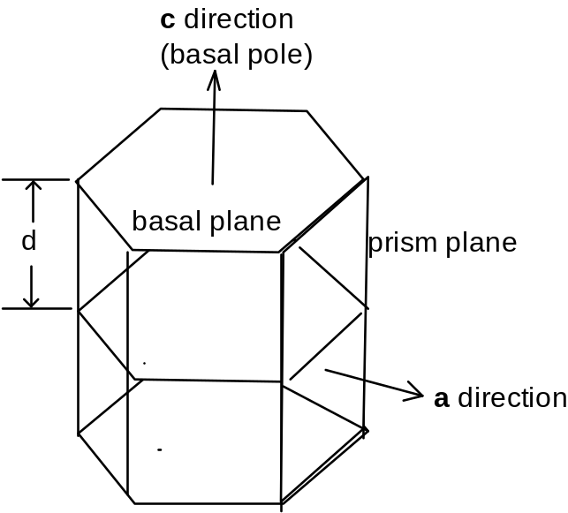

Fig. 17.1. Schematic of the crystal structure of α-Zr (hcp)

Typical physical properties of Zr and Zr alloys are given in Table 17.2. The physical properties can be quite different depending on the crystallographic direction.

Table 17.2: Selected physical properties of hcp Zr metal

 | Unit | Average | [110] direction | [0001] direction
Specific mass | kg.m⁻³ | 6500
Thermal expansion | K⁻¹ | 6.7x10⁻⁶ | 5.2x10⁻⁶ | 1.04x10⁻⁵
Young’s modulus | GPa |  | 99 | 125
Lattice parameter | nm |  | 0.323 | 0.515
Thermal conductivity | W.m⁻¹K⁻¹ | 22
Specific heat | J.kg ¹K⁻¹ | 276
Thermal neutron capture cross section | barns | 0.185

17.3.1. Allotropic phase change

At 865ºC, Zr undergoes an allotropic transformation from the low temperature hexagonal close packed phase (α  phase) to body centered cubic (β phase). On cooling, the transformation is either martensitic or bainitic, depending on the cooling rate, with a strong epitaxy of the α platelets on the old β grains according to the scheme proposed by Burgers [7] in 1934:
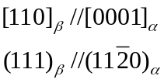 (17.1)

where, as usual, the square brackets stand for planes while the round brackets correspond to directions. This orientation relationship is illustrated in Figure 17.2. A distorted hexagonal unit cell is picked out of the bcc unit cell. The distortions necessary to map one lattice onto the other are at the most 10%, for the orientation relationship expressed in equation 17.1. This helps minimize the strain energy associated with the transformation.
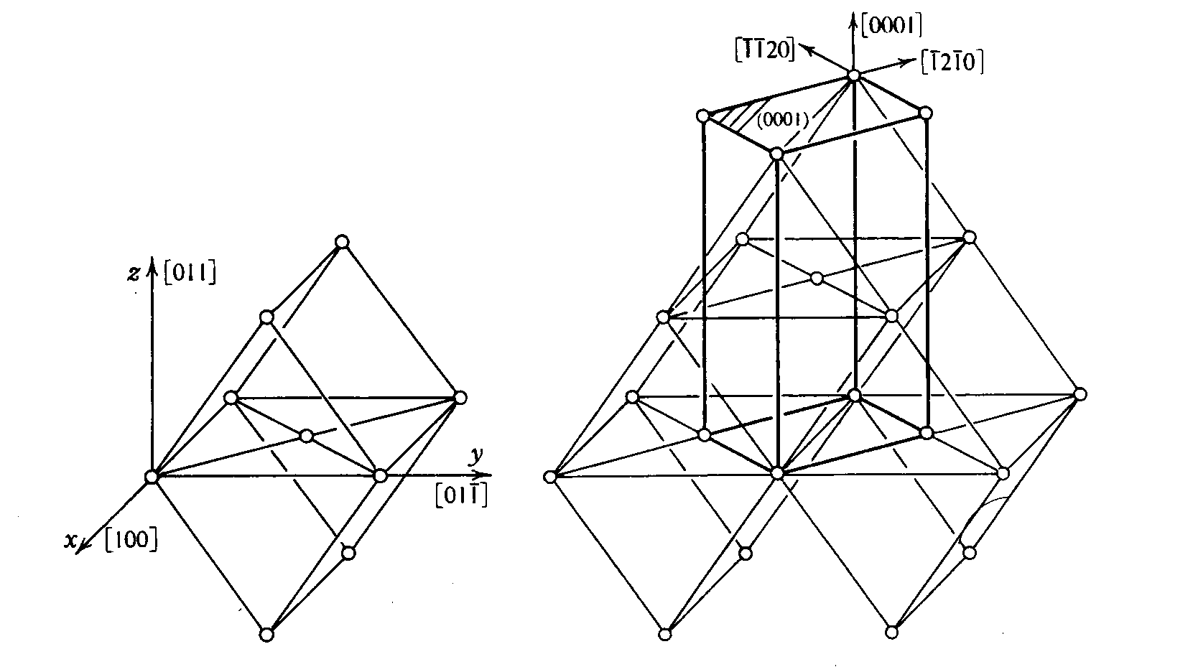

Figure 17. 2. The orientation relationship between β-Zr (bcc) and α -Zr (hcp) from [8].

This orientation relationship is based on the closest packed planes in the two structures (the 110 plane in the bcc structure and the 0001 plane in the hcp) and the closest packed directions (111 in bcc and 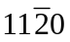in hcp) being parallel to each other. Since there are four [110] planes and three independent () directions, there are twelve variants of the orientation relationship above.

The melting point is 1860ºC, so that zirconium can be classified as a weak refractory metal. Although the alloying additions that convert Zr to Zircaloy change the transformation temperature and introduce a 150ºC temperature region in which the α and β phases coexist, the nature of the α - β transformation is basically the same as in pure Zr. This crystallographic transformation influences the microstructure of the final product and is exploited in the fabrication of tubing and plates.

17.3.2. Alloys and alloying elements

Various alloying elements have been tried to improve the corrosion resistance of pure Zr. The effect of these alloying additions on corrosion is discussed in Chapter 21. These alloying elements can be divided into two main types: alpha-stabilizers, such as Sn and Nb which tend to be in solid solution in the zirconium matrix, and beta-stabilizers, such as Fe, Cr and Ni, which tend to be sequestered in second phase precipitates in the alloy matrix. Both types of alloying elements are used in Zr alloys used for nuclear fuel cladding. Because of this, all zirconium alloys used for nuclear fuel cladding consist of an alpha Zr matrix with alloying elements in solution, and second phase particles, made up of the alloying elements whose concentrations exceed the solubility limits in the alpha Zr matrix.

The choice of which alloying elements to use has been done mostly by trial and error, often requiring a compromise between optimizing corrosion behavior and optimizing mechanical properties or dimensional stability. In addition to metallurgical considerations, such alloying elements need to have relatively low neutron absorption cross sections, which effectively eliminates elements such as Hf, Au, Cd, etc.. Furthermore, as mentioned above, zirconium has a strong affinity for hydrogen, nitrogen and oxygen, and so these elements need to be controlled during fabrication. Typical acceptable concentration limits are (in ppm by weight): O: 1400 ± 200; N: < 80; H: < 25.
The relative solubility of the various alloying elements in the α and β phases is one of the bases for the choice of additions as well as heat treatments.

17.3.3. Diffusion of alloying elements

The diffusion of alloying elements determines the kinetic of processes such as phase transformations where the rate limiting step is the transport of elements in the solid state. Solid state diffusion in Zr alloys however, is extremely complex, for two reasons; (i) the diffusion coefficients change markedly with crystallographic orientation and (ii) impurities have a marked effect on the migration of point defects and of other alloying elements.

Much of the experimental data in this area has been reviewed and summarized by Hood [9] in the plot shown in Figure 17.3. It is clear from the picture that there is a wide range of diffusion coefficients in Zr, divided mainly among fast diffusers (H, Fe,Co,Ni, Cr, Cu,O, N) and slow diffusers such as all the substitutional elements and the rare earths. The fast diffusing small solutes (H, Fe, Ni, up to O and N) exhibit activation energies between 0.6 and 2.5 eV and pre-exponential factors of 10⁻⁷ to 10⁻⁴ m².s⁻¹. Hood relates this to the relative atomic sizes: as the atomic size of the diffusing species increases, the diffusion coefficient decreases. The larger solutes are thought to migrate substitutionally and have activation energies of 2.8-3.3 eV with large pre-exponential factors. There are many questions about self-diffusion in alpha-Zr, but the best estimates give the migration energy to be 1.4 eV and the formation energy to be 1.9 eV, for an activation energy of 3.3. eV for vacancy mediated self diffusion in alpha Zr.

The diffusion along the a and c axes in Zr is generally different, but the anisotropy appears to be low for self diffusion by a vacancy mechanism [10]. It should be noted that the determination of such anisotropies in standard diffusion experiments may not capture anisotropies that could be present under irradiation. For example diffusion occurs by a vacancy mechanism in alpha-Zr outside irradiation, due to the very low concentration of interstitials found in thermal conditions. However under irradiation a high supersaturation of interstitials can exist which could contribute significantly to diffusion processes. If interstitial diffusion were anisotropic, then so would be diffusion under irradiation in contrast to purely thermal behavior. The determination of such diffusion anisotropies is important: a factor of two in the diffusion anisotropy has been shown to produce significant effects in sink biases and microstructural evolution through the so-called DAD (Diffusion Anisotropy Difference) effect [11], as discussed in Chapter 27. Finally, the effect of impurities has to be considered: substitutional diffusion in Zr has been shown to be dominated by the effect of residual Fe, which through an unknown mechanism reduces the migration energy from 1.4 eV to approximately 0.7 eV.

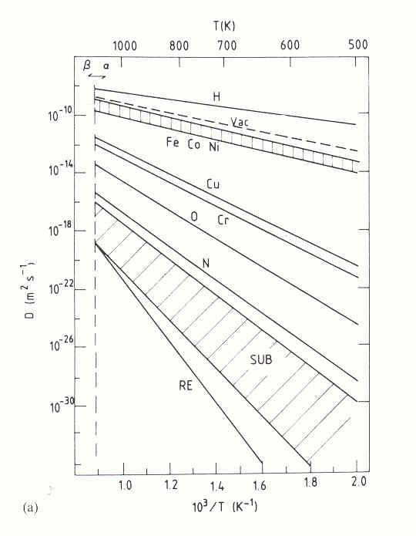
Figure 17.3. Diffusion coefficient (m²/s) (in log scale) as a function of inverse temperature (1/K) for various solutes in alpha Zr. “SUB” stands for substitutional solutes, “RE” for rare earths, and “VAC” is the vacancy diffusion coefficient. [reference]

17.4 Commercial Zirconium Alloys

The zirconium alloys in use today for nuclear applications are limited in number: besides pure Zr, only four alloys are currently listed in the ASTM standards. Those are shown in table 17.3. The first three are used for cladding and structural materials, such as guide tubes and channel boxes in PWRs and BWRs and structural materials in CANDU reactors, while the fourth one, grade R 60904, is used exclusively in pressure tubes for CANDU reactors. For cladding tubes, only Zircaloy-2 and -4 are listed in ASTM B 811-90. The alloys ZIRLO and M5 are widely used for modern cladding, but do not yet have an ASTM designation.

Table 17.3: Composition range of standard Zr alloys (in each case the balance is Zr).

ASTM Ref. | R 60802 | R 60804 | R 60901 | R60904 | - | -
Common Name | Zircaloy-2 | Zircaloy-4 | Zr-Nb | Zr Nb | ZIRLOTM | M5TM
Alloying elements (weight %)
Sn | 1.2-1.7 | 1.2-1.7 | - | - | 0.96 | -
Fe | 0.07-0.2 | 0.18-0.24 | - | - | 0.1 | -
Cr | 0.05-0.15 | 0.07-0.13 | - | - | - | -
Ni | 0.03-0.08 | - | - | - | - | -
Nb | - | - | 2.4-2.8 | 2.5-2.8 | 0.99 | 1.0
O | 1000-1400 ppm |  | 0.09-0.13 | TBS | 1430 ppm | 1250 ppm
Impurities (maximum weight ppm)
Al | 75 | 75 | 75 | 75 | - | -
B | 0.5 | 0.5 | 0.5 | 0.5 | - | -
Cd | 0.5 | 0.5 | 0.5 | 0.5 | - | -
C | 270 | 270 | 270 | 150 | 65 | -
Cr | - | - | 200 | 100 | - | -
Co | 20 | 20 | 20 | 20 | - | -
Cu | 50 | 50 | 50 | 50 | - | -
Hf | 100 | 100 | 100 | 50 | - | -
H | 25 | 25 | 25 | 25 | - | -
Fe | - | - | 1500 | 650 | - | -
Mg | 20 | 20 | 20 | 20 | - | -
Mn | 50 | 50 | 50 | 50 | - | -
Mo | 50 | 50 | 50 | 50 | - | -
Ni | - | 70 | 70 | 35 | - | -
N | 80 | 80 | 80 | 65 | - | -
Pb | - | - | - | 50 | - | -
Si | 120 | 120 | 120 | 120 | - | -
Sn | - | - | 50 | 100 | - | -
Ta | - | - | - | 100 | - | -
Ti | 50 | 50 | 50 | 50 | - | -
U | 3.5 | 3.5 | 3.5 | 3.5 | - | -
V | - | - | - | 50 | - | -
W | 100 | 100 | 100 | 100 | - | -
Other alloys have been developed during the history of nuclear power, but except for the Zr 1% Nb alloy used for cladding in Russian PWRs (VVER), they are no longer in use.

The main alloying elements and their effects on the alloy microstructure are now considered in turn. The reader can refer to the phase diagrams shown in Chapter 10. We first consider the elements with significant solid solubility in α Zr, which are Sn, Nb, and O. Tin is an α stabilizer, and at the concentration of 1.2-1.8 % used in Zircaloys it should form intermetallic precipitates. Such precipitates are however not observed, likely for kinetic reasons, and, Sn is found in the α phase in solid solution. Tin was originally used to improve corrosion resistance specially by mitigating the deleterious effect of nitrogen. Due to better control of processing parameters, and consequently of nitrogen content, the usage of tin tends to decrease in the current alloys (e.g. low-Sn Zircaloy-4 as mentioned below). Tin, however, also has some impact on mechanical properties, by increasing the tensile yield strength, and therefore it is not completely eliminated from the alloys.

Niobium is a β stabilizer. At high temperature a complete substitutional solid solution exists from pure β-Zr to pure β-Nb (both bcc). Alloys that have high Nb concentration (>0.4%) tend to form β Nb, or depending on the heat treatment, β-Zr, often at the monotectoid composition of 18.5%. Thus, alloys such as M5 and ZIRLO exhibit bcc β Nb precipitates. In the presence of Fe (even impurity levels), Nb can also be found in Laves phase type precipitates such as occurs in ZIRLO (see below). In the Zr-2.5%Nb alloy used in CANDU reactors, a two-phase structure exists in which elongated grains of α Zr and β Nb alternate; such a structure is metastable and can evolve with heat treatment and/or irradiation.

Oxygen is added to the compacts before melting, as small additions of ZrO₂ powder. The usual oxygen content is in the range of 800-1600 wt. ppm and its purpose is to increase the mechanical properties by solution strengthening (a 1000 wt. ppm oxygen addition increases the yield strength by 150 MPa at room temperature). Oxygen is an α-stabilizer, expanding the α region of the phase diagram by formation of an interstitial solid solution. The Zr-O phase diagram given in Chapter 10 shows that at high oxygen concentration, the α phase reaches the liquid: During high temperature oxidation, simulating a reactor accident, a layer of α stabilized zirconium is found between the β quenched structure and the zirconia (see Chapter 24).

Hydrogen is not an alloying element by design, but its behavior within the alloy has to be assessed, since hydrogen is presented at low levels in the as-fabricated material and it is absorbed into the cladding during waterside corrosion (Chapter 22). Hydrogen atoms are located at tetrahedral sites of the hcp cell of the Zr matrix up to the solubility limit (about 15 ppm at 200 C and 200 ppm at 400° C), see Chapter 22. Above the solubility limit, hydrogen precipitates as the equilibrium fcc phase (Zr H_{1.66}). The corresponding phase diagram is given in chapter 10. Given the texture of Zr sheet tubing, the hydrides precipitate as circumferential platelets. Because these hydrides are more brittle than the matrix, this orientation minimizes the effects on mechanical properties, but different stress states can cause these hydrides to reorient.

Another class of alloying elements form second phase precipitates with specific crystal structures. Iron, chromium and nickel are β-stabilizers, because, in their phase diagrams, those elements have an eutectoid decomposition of the β phase (see phase diagrams chapter 10). They were added to the early Sn-based alloys (Zircaloy-1) after an accidental stainless steel pollution of a melting lot showed significantly improved corrosion behavior, which led directly to Zircaloy-2 and Zircaloy 4. At common concentrations, these elements are fully soluble in the β phase. The temperature of dissolution of those elements is in the range of 835-845ºC - i.e. in the upper α+β range.

In pure α -Zr their solubility is very low: in the range of 120 wt. ppm for Fe and wt. 200 ppm for Cr at maximum solubility temperature, although in Zr alloys the solubility of these elements may be higher. For the Zr-Cr and Zr-Ni binary alloys, the stable forms of the second-phase precipitates are Zr₂Ni or ZrCr₂. These phases are effectively the ones observed in the Zircaloys, with Fe substituting for the corresponding transition metal. Therefore the general formulae of the intermetallic compounds in Zircaloy are Zr₂ (Ni,Fe) (with body centered tetragonal structure) and Zr(Cr,Fe)₂ (with either hcp or fcc crystal structure). The Zr(Cr,Fe)₂ precipitates have a crystal structure that is in both the hcp or fcc formats part of a larger class of archetypical crystal structures observed in the vast majority of intermetallic compounds, called Laves phases. These structures have the characteristic of maximizing the occupation of space in binary compounds[12].

In Zircaloy-4, the Fe/Cr ratio measured in the precipitates is the same as the nominal composition of the alloy. In Zircaloy-2 alloys, the partitioning of Fe between the two types of intermetallic phases leads to a more complex relationship between nominal composition and precipitate composition, giving a broad range of Fe/Cr ratio in Zr(Cr,Fe)₂, and Fe/Ni ratio in Zr₂(Fe,Ni) . The orthorhombic Zr₃Fe phase which appears in the binary Zr-Fe diagram is only found in Zircaloy-4 with very high Fe/Cr ratios, probably because its formation is too sluggish compared to the formation of the Zr(Cr,Fe)₂ precipitates. As a result, upon cooling from the β-phase the Zr(Cr,Fe)₂ precipitates form first and consume the available Fe. In ZIRLO and M5, in addition to β-Nb precipitates, hcp Zr-Nb-Fe precipitates are observed (although Fe is not an alloying element per se, it is present in small quantities in these alloys).

Table 17.4 shows the crystal structures and lattice parameters of common second phase particles in Zr alloys.

Table 17.4: Crystal Structures and lattice parameters of second phase precipitates in Zr alloys

Alloy | Precipitate Composition | Crystal Structure | Lattice parameters (nm)
Zircaloy-4 | Zr(Cr,Fe)₂  Zr₃Fe | hcp C14  or fcc C15  orthorrhombic | a= 0.501 and c=0.822  a=0.719 nm  a=0.332, b=1.10 and c=0.88
Zircaloy-2 | Zr(Cr,Fe)₂  Zr₂(Ni.Fe) | hcp C14  or fcc C15  bct | a= 0.501 and c=0.822  a=0.719 nm  a=0.69 and c=0.53
ZIRLO | ZrNbFe  β-Nb | hcp C14  bcc | a=0.54 and c=0.87  a=0.331
M5 | β-Nb | bcc | a=0.331

A small amount of ZrFeNb laves type precipitates also forms in M5.

The size of the second-phase precipitates impacts alloy properties, especially the corrosion rate. Better uniform corrosion resistance is obtained for Zircaloys used in PWRs if they contain large precipitates, while better resistance to localized forms of corrosion is seen in BWRs in materials that have finely distributed small precipitates (See Chapter 22). Precipitation after β-quenching is rapid and the coarsening rate of those precipitates controls their sizes in the final microstructure. It is thus necessary to consider the complete history of the various heat treatments following the final β-quenching to predict the precipitate size distribution. The temperatures and durations of the annealing operations control the properties of the finished tubing. For Zircaloys, a single parameter can account for the effects of multiple heat treatments on properties such as strength, ductility, and even corrosion resistance. This parameter is called the annealing parameter, and is defined by:

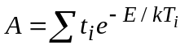 (17.2)

where t_{i} (h) and T_{i} (K) are, respectively, the time and temperature of annealing step i.
E is an empirical activation energy; the value of E/k_{B} used is 40,000 K.
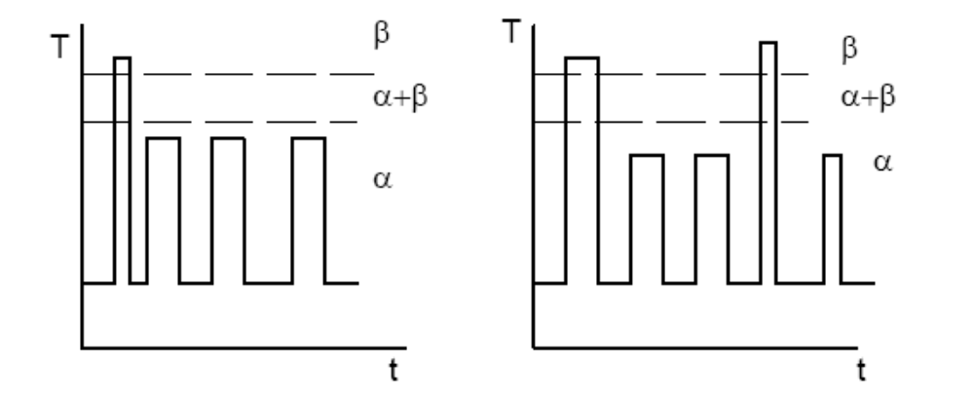
(a)
(b)

Figure 17.4: Schematic time-temperature sequences during heat treatment of Zr alloys, showing (a) early and (b) late beta-quench.

The final anneal controls the microstructure of the product. At 480ºC, most of the cold work introduced in the preceding step is retained, but some of the internal stresses created by the deformation are reduced (stress relieved). At 560ºC, the cold work is completely removed (the product is “fully-annealed) and the grains are returned to a equiaxed shape (“fully recrystallized”). Each type of Zircaloy is called for in different core components, depending on the combination of strength versus ductility required. Figure 17.5 shows the microstructures of these two products. The small spots in the light grains are the second-phase precipitates. The elongation of the grains induced by the fabrication process is evident in the cold-worked, stress-relieved material (right hand micrograph). In the fully-recrystallized specimen, the higher temperature anneal removes this elongation (left hand micrograph).

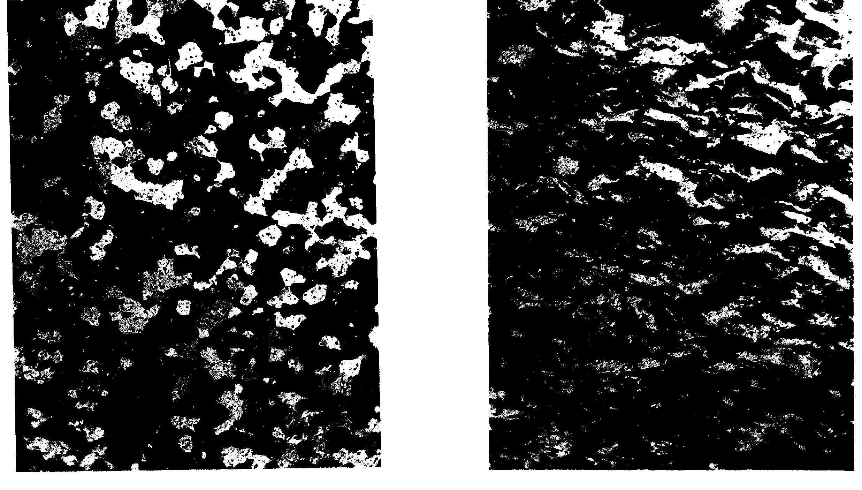

Fig. 17.5 Microstructure of Zircaloy tubing annealed for 2 hours at two different temperatures. Left: at 580ºC (fully-recrystallized); right: at 480ºC (cold worked stress-relieved)

The precipitate structure resulting from those heat treatments in Zircaloy is illustrated in the transmission electron micrographs in Figure 17.6 (a) and (b), In the transmission electron micrographs, the precipitates are revealed by diffraction contrast, as dark particles. It is clear that the precipitates formed in the alloy with high annealing parameter (a) and early beta-quench are much bigger than those in the beta quenched samples, although they have the same crystal structure.

The process of introducing new alloys is necessarily slow because safety concerns restrict the introduction of new alloys, as a large amount of data needs to be accumulated to verify the safe behavior of fuel elements in case of reactor accidents. In the case of ZIRLO, for example, the initial testing started in the early 1970s and extensive commercial use started in the early 1990s. It is important to note that the annealing parameter defined in equation 17.2 is only valid for Zircaloys, and cannot meaningfully be applied to other alloys, especially Zr-Nb alloys, which exhibit other phases. The two modern alloys, ZIRLO and M5 have particular microstructures and precipitates crystal structures, brought about by specific heat treatment schemes. In both cases the resulting microstructures contain beta Nb precipitates and ZrFeNb Laves phases of the same type as Zr(Cr,Fe)₂ , as result of Fe impurities in the melt. The proportion of Fe is higher in ZIRLO, which results in a higher proportion of ZrFeNb precipitates than in M5, and ZIRLO has added Sn. Contrary to Zircaloy, both modern alloys are defined by the specific microstructure and heat treatement (i.e., an alloy with the same composition as ZIRLO is not considered ZIRLO unless it has the same proprietary treatment given by Westinghouse, and the same is true for M5).

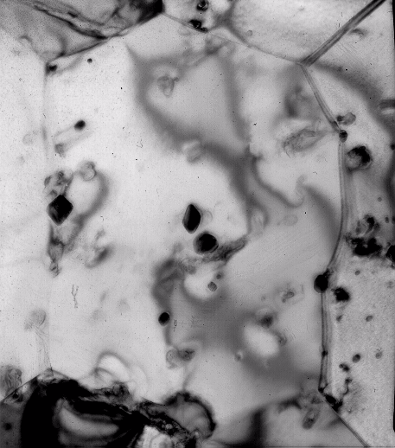  Zr matrix  precipitates  1 μm | Need  Picture of beta quenched Zircaloy
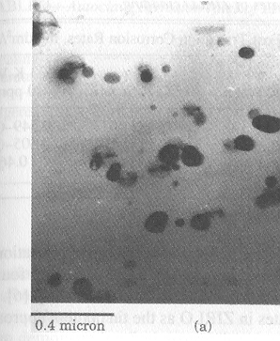 | 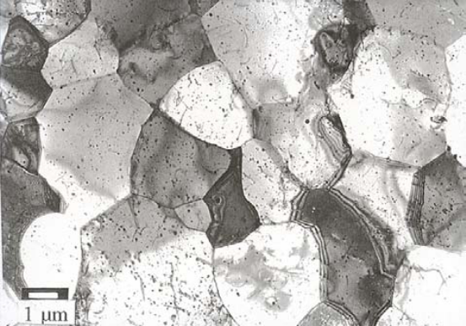
Figure 17.6. Transmission electron micrographs showing the microstructure of various zirconium alloys in (a) Recrystallized Zircaloy-4, (b) Beta quenched material, (c) As-fabricated ZIRLO and (d) M5 Alloy showing homogeneous distribution of precipitates ([13]).

17.5. Fabrication of Tubing and Sheet

The ore most frequently used for the production of zirconium is zircon (ZrSiO₄) which has a worldwide production of about one million metric tons per year. The zircon is converted into ZrCl₄, the naturally occurring Hf (about 2% in the ore) is extracted and the result is sponge Zr which is the basis of ingot production. For industrial alloys, the other alloying elements (including oxygen in the form of ZrO₂) are melted with the sponge in a vacuum furnace to produce the ingots.

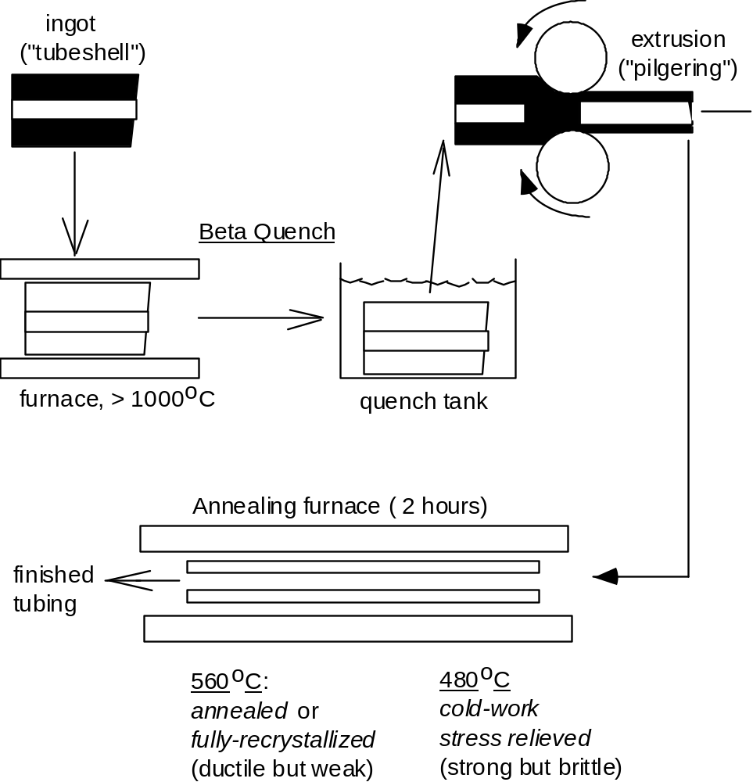

Fig. 17.7 Zircaloy Tubing Fabrication Process

17.7 shows schematically the fabrication process of Zr tubes. To fabricate either tube- or plate-shaped material, the first step of mechanical processing is forging or hot rolling in the β phase, at a temperature close to 1050 C. Homogenizing in the beta range causes the alloying elements in second phase particles to dissolve completely in the beta matrix, and the grains grow significantly (after half an hour at high temperature the grains can reach mm). Upon quenching, the β grains transform to α needles with separation of the β stabilizing elements to the grain boundaries. The β to α transformation follows the scheme shown in Fig. 17.4 so that twelve variants of the orientation relationship exist. As the beta grains cool down, any of these variants can be chosen at random, leading to the simultaneous growth of these variants together and to the “basket weave” structure shown in Figure 17.8.

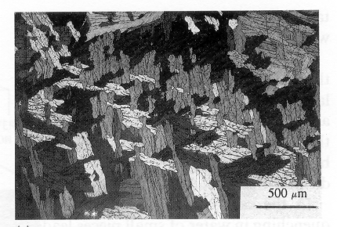

Figure 17.8: Polarized light micrograph of beta quenched material showing basket-weave alpha grains with four different orientations within the same previous beta grain.

Hot extrusion is used to obtain tube shells, while hot rolling is used for flat products. At that stage a β quench is performed to increase the corrosion resistance of the final product. This treatment controls the distribution of second phase particles, if no further processing is performed above 800°C. Further reduction in size is obtained by cold rolling either on standard or pilger-rolling mills. Low temperature recrystallization is performed between the various size reduction steps. Final manufacture of tubing is accomplished by successive operations of tube reduction or cold working with intermediate low temperature anneals. The Zircaloy tubing is normally fabricated in two conditions: fully recrystallized (final anneal at 560 °C) or cold work stress relieved (if the final anneal is at 480° C), as shown in Figure 17.5.

17.6. Dislocation structure and deformation Mechanisms

A comprehensive review of the deformation and texture in Zr alloys has been published by Tenckhoff [3] and a summary is presented here. Like any commercial alloy, Zircaloy is a polycrystalline material composed of single-crystal units called grains or crystallites. These units are large-scale versions (~ 5 μm) of the structure depicted in Fig. 17.1. Although the grain shape is not a hexagonal prism, this polyhedron is commonly used to depict the orientation of the grains in a finished Zircaloy piece.

There are two main plastic deformation mechanisms available for a solid under stress: slip and twinning. As explained in Chapter 7, the dislocations that tend to form in a given crystal structure are those with the smallest burgers vectors, since the dislocation self-energy per unit line increases with b². An fcc metal typically deforms with the {111}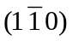family being active (meaning a dislocation with a habit plane in a 111-type plane slipping in a 110 type direction) . This slip family has twelve slip systems (four {111} type planes and three (110) type directions) evenly distributed in the reference sphere. In contrast, the hcp crystal lattice has less slip systems available within a slip family and these are distributed more asymmetrically in the reference sphere.

Figure 17.11 shows possible slip systems in hcp metals. Which slip system is activated in a particular hcp metal is primarily a function of the c/a ratio. In the ideal hcp structure the closest neighbors are the located at a distance 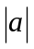 from each other in the 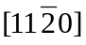 direction. Because in Zr the c/a ratio is less than ideal, the highest atomic density per unit area actually occurs in the prism planes rather than on the basal planes, so that is where dislocations tend to form. As a consequence, the primary slip system in Zr alloys is {1010}(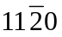), that is, the dislocation habit plane is in the prism plane and slip occurs in the direction (Fig.17.11a).

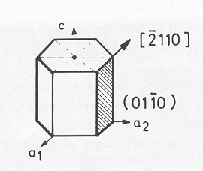  (a) | (b)  (c)  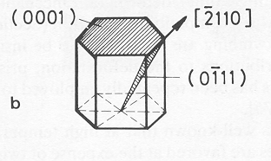 | 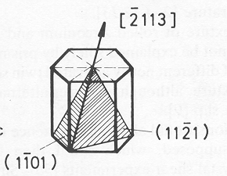

Fig. 17.11: Possible slip systems in hcp materials (a) prism slip {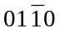}(), (b) basal slip {0001}() and (c) pyramidal slip {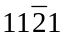}(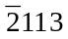). (reference)

This slip family comprises only three slip systems whereas five simultaneously operating slip systems are necessary to allow for deformation compatibility. Given that Zr alloys are reasonably ductile, other deformation mechanisms (such as slip in other systems and/or twinning) have to be present to allow for the Von Mises compatibility criteria to be satisfied during deformation. There are various primary and secondary slip systems and twinning systems which can become active depending on various factors, such as the stress state, and the percent reduction, in addition to the c/a ratio. Thus, slip on the 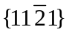 or 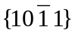planes with (c+a ) Burgers vectors can occur and also deformation by twinning may be activated depending on the stress state: for tensile stress in the c direction, {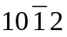}(1011) twins are the most frequent, while the 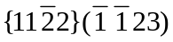 system is observed when compression is applied in the c direction.

17.7. Crystallographic Texture and Physical properties

The properties of the tubing produced by the fabrication method described above are directionally dependent, as result of the anisotropic crystal structure of α-Zr, coupled with nonrandom orientation of crystallites (grains) resulting from the fabrication process. This feature governs many properties relating to material behavior specially cladding deformation under irradiation by growth (increasing length) and creep (See Chapter 27).

This macroscopic anisotropy of material properties depends on two factors. First, the crystal structure of the alloy must be anisotropic, as it is in α-Zr. Second, the method of producing the tubing must induce a preferred orientation of the crystallites in the finished product. Properties of single crystals with cubic lattice structures vary with crystallographic direction. However, anisotropy in polycrystals of cubic materials is absent because the grains have no preferred orientation. The deformation caused by the diameter and wall thickness reduction in the extrusion step of the fabrication process produces the preferred orientation of the crystallites, which is termed crystallographic texture. Note that both conditions must be met in order for texture to develop. If the basic crystal structure is isotropic, as in stainless steel, finished pieces are macroscopically isotropic, irrespective of the deformation induced in the production process. Even if the crystal structure is anisotropic, texture does not develop without directionally-oriented processing steps, such as tubing extrusion.

The term texture denotes a quantitative measure of the directions in which specific poles (for example, basal poles for basal texture) point relative to the three macroscopic coordinate axes. We review the development and measurement of crystallographic texture in the following sub-sections

17.7.1. Texture formation during deformation

The origin of the crystallographic texture in Zr alloys lies in the fabrication processes of sheet rolling and tube reduction through extrusion. The development of texture results from the combined interaction of all these slip systems and twinning systems under the stresses created during the fabrication process. Zircaloy tubing manufactured by the extrusion produces grain orientations similar to those shown in Fig. 17.12. The majority of the basal poles lie approximately 30º off the radial (r) direction, 60º off the azimuthal (θ) or transverse (T) direction, and 90º from the axial (z) direction. That is, the basal pole preferred orientation is primarily in the radial-azimuthal plane about 30-40 degrees from the radial direction, with practically no poles pointing in the axial direction.
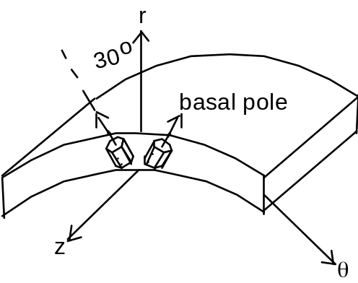

Fig. 17.12 Typical crystallographic texture of basal poles in Zircaloy tubing.

17.7.2. Representation and Measurement of texture

Texture measurements are performed by X-ray diffraction using the arrangement shown in Fig. 17.12. To measure basal pole texture, a source of monochromatic X-rays of wavelength λ mounted on the surface of a sphere is aimed at a specimen at the center of the sphere. A detector, also aimed at the specimen, is placed on the surface of the sphere at an angle 2θ from the source. The angle θ is chosen to equal the Bragg angle for diffraction from atomic planes separated by the distance d₀₀₀₁, the spacing of basal planes in the α-Zr crystal structure (Fig. 17.13):

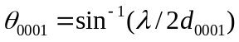 (17.3)

The line terminating at point P on the surface of the sphere in Fig. 17.13 is the bisector of the angle 2θ between source and detector. All grains (crystallites) in the specimen with basal planes perpendicular to this bisector satisfy the Bragg condition and produce a diffraction signal in the detector. Alternately, a diffraction signal is produced when the basal poles in the specimen lie in the same direction as the source-detector bisector.

The bisector direction is defined by the polar angle φ and by an azimuthal angle on the θ-z plane. For convenience in representing the diffracted X-ray intensity as a function of these angles, point P is projected to point P’ on to the upper θ-z plane, which is called the stereographic projection plane. The concentric circles on this plane represent the locus of points P on the sphere with constant values of the polar angle φ. The point P is moved over the upper hemisphere by moving the X-ray source-detector combination over the surface of the sphere, keeping the Bragg angle φ fixed. By recording the diffracted X-ray intensity as P’ moves on the projection plane, the number of crystallites in the specimen with basal poles defined by the point P on the sphere is determined.

In Fig. 17.13, the reference direction for defining the angle φ is the tube specimen’s radial direction (or the normal direction for a sheet specimen). The diffracted intensities corresponding to different locations of point P on the sphere are projected on the θ-z plane as contours of constant relative intensity. The contour plot obtained from the basal pole orientation of Fig. 17.12 is shown in Fig. 17.14. The two symmetrically-placed peaks along the θ direction at φ = ± ~40º correspond (roughly) to the orientations of the two crystallites drawn in Fig. 17.12.

φ
θ
θ
N
T
R
P’
P
x-ray detector
x-ray source
stereographic projection plane

Fig. 17.13. Principle of the stereographic projection method to prepare pole figures for measurement of Zircaloy texture

Contour plots such as the one shown in Fig. 17.14 are called basal pole figures because the X-ray apparatus is set to respond only to basal planes in the α-Zr structure. It is a radial pole figure because the reference direction is the radial coordinate of the tube specimen. Basal pole figures for the θ and z reference directions can be obtained in a manner similar to that described above for the r direction. To obtain pole figures for a generic plane hkil we would change the angle of the detector to 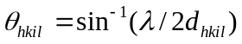

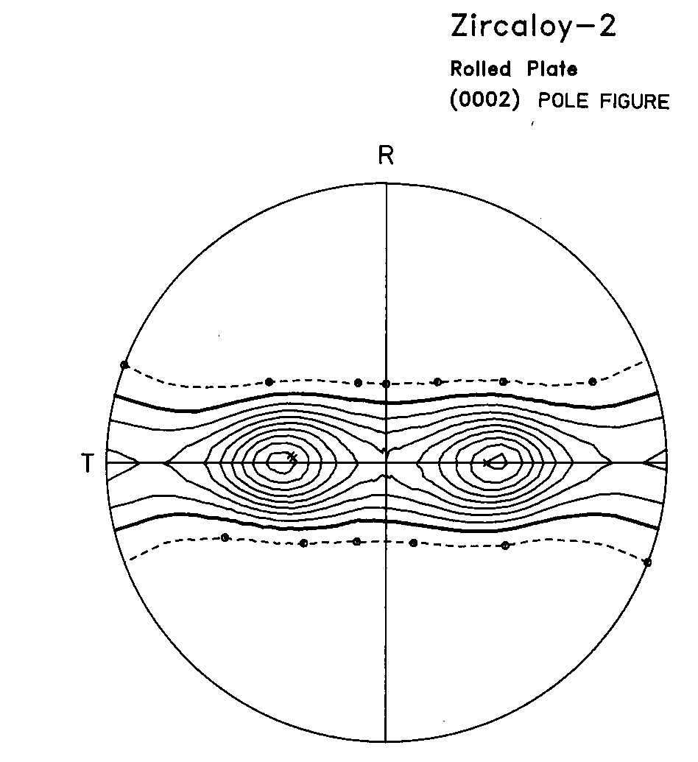

Fig. 17.14. Basal Pole Figure for Zircaloy-2 rolled plate on stereographic projection plane. The bold line indicates the average basal pole intensity, while successive solid lines indicate increasing intensity, up to nine times the average intensity. The dotted line represents half the average intensity (Courtesy of John Root, AECL).

************

Example 17.1: Using the stereographic projection geometry verify that the maxima of the basal pole intensity in Figure 17.14 are located about 40 degrees from the normal direction.
N
P_{C}
The geometry is
P’
P_{R}

P
φ
y
R

ζ

From Figure 17.14, the maxima are located at about 0.35 of the full diameter. Assuming this number is exact, because the full diameter is given by the projection P_{R}, then this represents 0.35 of 2R, i.e.:

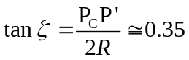

If the radius of the sphere is R we can show that

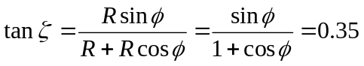

the angle φ gives the normal direction angle to the direction of the maxima of the basal poles. Solving the equation above numerically for φ gives φ=38.6 degrees.

************

17.7.3 Property anisotropy and texture parameters

While basal pole figures provide useful qualitative insight into Zircaloy texture, they need to be reduced to simple quantitative measures for use in component design and specification. For example, the thermal conductivity of α-Zr (or Zircaloy) in <c> (direction parallel to basal poles) is significantly different from that in <a> (perpendicular to basal poles). If these two quantities are known, and the texture (or preferred orientation) is represented by Fig. 17.14, the relevant question is what is overall the thermal conductivity of Zircaloy tubing in its radial direction? If the basal pole orientation is that shown in Fig. 17.12, the thermal conductivity in the radial direction, κ_{r}, will depend on κ_{<c>} and κ_{<a>} with the contribution of each dependent on the average angle that the basal poles make with the r direction. A quantitative measure of the average tilt of the basal poles can be obtained from the pole figure; the other step is to combine this tilt measure with the properties in the two principal crystallographic directions in order to determine the average value of the property in the r direction.

*****************************

Box 17.1 Anisotropy of material properties

An analysis is provided here using the thermal conductivity as an example of a direction-dependent property of α-Zr. The same theory applies to other properties, such as the atom self-diffusion coefficient and the yield strength. For generality, property differences in all three spatial dimensions are used in the analysis and later reduced to the case of the two principal crystallographic directions applicable to α-Zr.

Figure 17.15 shows a coordinate system oriented with principal directions coincident with the crystal axes of a single-crystal specimen. The thermal conductivities in these directions are κ_{x}, κ_{y}, and κ_{z}. A temperature gradient 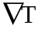(a vector) is imposed on the crystal at polar angle φ and azimuthal angle α. The temperature gradient can be resolved into components 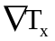, 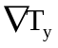, and 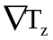, which generate heat fluxes along the crystal axes of:

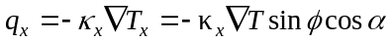

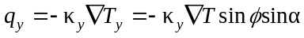 (17.4)

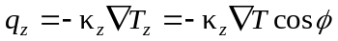
φ
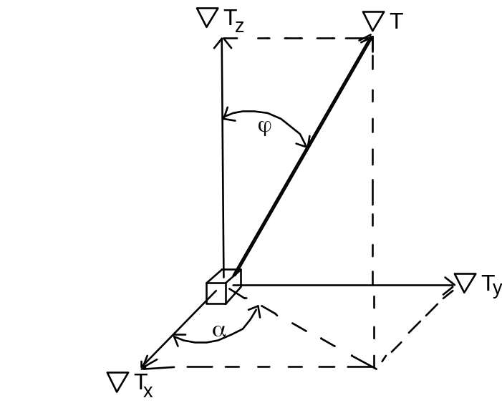

Fig. 17.15 Resolving a temperature gradient along crystal axes

The next step is to reverse the preceding process: the heat flux components are resolved in the direction of and summed to give the heat flux q in the same direction. Figure 17.16 shows how to do this for the contributions from q_{z} and q_{x} (the q_{y} diagram is omitted for clarity). Resolving q_{z} in the direction of q and using Eq (17.4) for q_{z} yields the length OB:

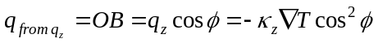

The component due to q_{x} is:

Without demonstration, the component due to q_{y} is:

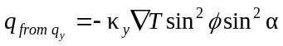

φ
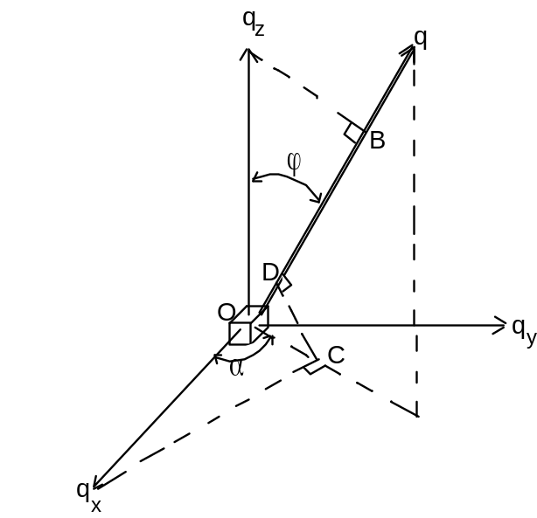Fig. 17.16 Resolving heat fluxes along crystallographic axes on to an arbitrary direction

Since Fourier’s law is q = -κ and q is the sum of the above three components, the thermal conductivity in the direction of is:

When the properties perpendicular to the basal pole (z direction) are equal, as in α-Zr, then κ_{x} = κ_{y} and the above equation reduces to:

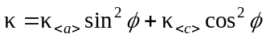 (17.5)

where the z direction has been labeled <c> and the two transverse directions denoted by <a>. Note that the average property does not depend on the azimuthal angle α.

Close box 17.1

For a cubic crystal, such as stainless steel, properties in all three crystal directions are equal, and the thermal conductivity is the same in any direction.

The analysis resulting in Eq (17.5) applies to a single crystal of α-Zr oriented so that all basal poles make the same angle φ with the arbitrarily-chosen reference direction. For a polycrystal of Zircaloy, the distribution of basal pole directions must be taken into account using as an example the basal pole figure of Fig. 17.14. In this case, the arbitrary direction in Figs. 17.15 and 17.16 is the longitudinal direction of the sheet and the concentric circles in Fig. 17.13 represent constant values of φ. The contours in Fig. 17.13 are a representation of the detected X-ray intensity per unit solid angle at a location on the stereographic projection (or on the sphere) fixed by the values of φ and α. This intensity, denoted by i(φ,α), is proportional to the number of basal poles pointing in the same direction, also per unit solid angle. Since the directional value of the property (Eq (17. 5)) is independent of azimuthal angle, the intensity can be integrated over α to give the intensity per unit conical solid angle:

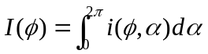 (17.6)

Since texture is such an important determinant of Zircaloy properties, a quantitative method for measuring texture is required. The complete determination of the texture is given by the orientation distribution function (ODF), but for most purposes, simply the resolved fraction of poles oriented in a certain macroscopic direction is sufficient to characterize texture. I(φ)dΩ is proportional to the number of basal poles in the differential solid angle dΩ = 2π sinφ dφ. This differential solid angle is the area between one of the circles in Fig. 17.12 and another circle dφ further out.

The total number of basal poles in the specimen is the integral of I(φ) over the entire hemisphere or the complete area of the stereographic projection in Fig. 17.13. The resolved fraction of basal poles in the polar angle annulus between φ and φ + dφ is:

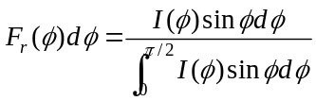 (17.7)

Where the subscript r on F_{r} is a reminder that the direction from which the polar angle φ is measured is the radial direction of the tube specimen.

The modified form of Eq (17.7) that accounts for the distribution of basal poles in the polycrystalline specimen is:
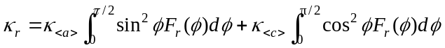

Since sin²φ = 1 – cos²φ, this equation can be written the following compact form:

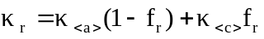 (17.8)
where
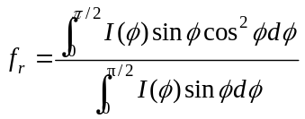 (17.9)

f_{r} is called the radial texture parameter of the tube. This quantity, along with the corresponding values f_{θ} and f_{z} in the azimuthal and axial directions, constitute a concise measure of the preferred orientation of the basal poles (or texture) in Zircaloy tubing. These are commonly called the Kearns factors [14]. In addition, the texture parameters permit calculation of any property of a Zircaloy component in any direction by use of formulae analogous to Eq (17.8). The texture parameters in the three principal directions satisfy:

f_{r} + f_{θ} + f_{z} = 1 (17.8)

Random texture corresponds to f_{r} = f_{θ} = f_{z} = 1/3. Typical basal pole texture parameters of Zircaloy tubing are f_{r} = 0.60, f_{θ} = 0.33, f_{z} = 0.07.

17.8. Fuel Elements and Assemblies

The finished tubes are used in fabricating fuel rods (also called fuel elements), which are used in turn to construct the fuel assemblies. Each fuel assembly contains 62 fuel rods (BWR) or over 200 fuel rods (PWR). Tens of these fuel assemblies constitute the reactor core. They are arranged together in a manner dictated by fuel management to optimize various parameters, such as fuel utilization, peak temperatures, and reactivity control.

The main function of the fuel element is to protect the fuel from the coolant and to contain the fission products, while allowing efficient heat transfer from the fuel to the coolant. The design of the fuel elements also has to be inherently safe under accident conditions. The fuel assembly also provides a stable geometry with proper spacing to allow for coolant flow and heat transfer, and enough coolant to allow sufficient moderation. The fuel assemblies also need to provide a fixed geometry that allows for the prompt insertion of the control rods, in case the reactor needs to be shut down. Other economic design considerations are optimum fuel management, ability to attain high burnup, reliability, realistic manufacturing process and quality control [15]. In addition, by bundling the fuel rods together the fuel assemblies provide a rigid structure for transportation and for ease of fuel handling upon insertion and removal from the core.

Much effort goes into the proper design of fuel assemblies, as many of the most common degradation mechanisms that cause cladding failures are caused by problems such as fretting and flow-induced vibrations, which are a function of fuel assembly design.
17.8.1. Cladding Geometry

Since the cladding is a cylindrical tube, the only geometrical design features are length, diameter, and wall thickness. The length is fixed at ~ 4 m by considerations of axial neutron leakage from the core and pressure drop of the coolant through the core. The diameter is determined from heat transfer considerations; for a fixed fission rate density (or volumetric heat production rate) in the fuel, the maximum fuel temperature is proportional to the square of the cladding diameter. This fact favors small-diameter cladding. However, a large number of small-diameter fuel rods is more costly to fabricate and requires more metal than a small number of large rods. The optimization of this aspect of fuel element design results in cladding outer diameters in the range of 10–11 mm.

The thickness of the cladding wall is also dictated by conflicting performance requirements. The effect of loss of metal by inner or outer corrosion is less important for thick cladding than for thin-wall tubing. The stress produced in the cladding for the same mechanical loading, either external from the coolant or internal from fission-product swelling of the fuel, is inversely proportional to the wall thickness. Mechanical stability favors thick-walled tubing; cladding with the proportions of a gun barrel would make a very rugged container for the fuel. On the other hand, thick cladding is detrimental to neutron economy, increases the volume of the reactor core, raises fuel temperature, and costs more than thin-wall tubing. The compromise between these competing demands has produced cladding wall thicknesses of 0.6 ~ 0.7 mm.

17.8.2. Fuel-Cladding Gap

The finer points of the design of the fuel rod are directed in large part towards mitigating the deleterious effects of fission gases (chiefly xenon) that are released from the fuel during operation. Fission gas collects mainly in the two void spaces in the rod, namely the radial gap between the fuel and the cladding and the empty space above the fuel stack, which is called the plenum.

The thickness of the gap in the as-fabricated fuel element is a prime design specification. The gap is filled with a gas, which is a very effective thermal insulator (even compared to ceramic oxides). To alleviate this effect, the rod is sealed while filled with helium, chosen because of its inertness and high thermal conductivity. Since the temperature of the cladding
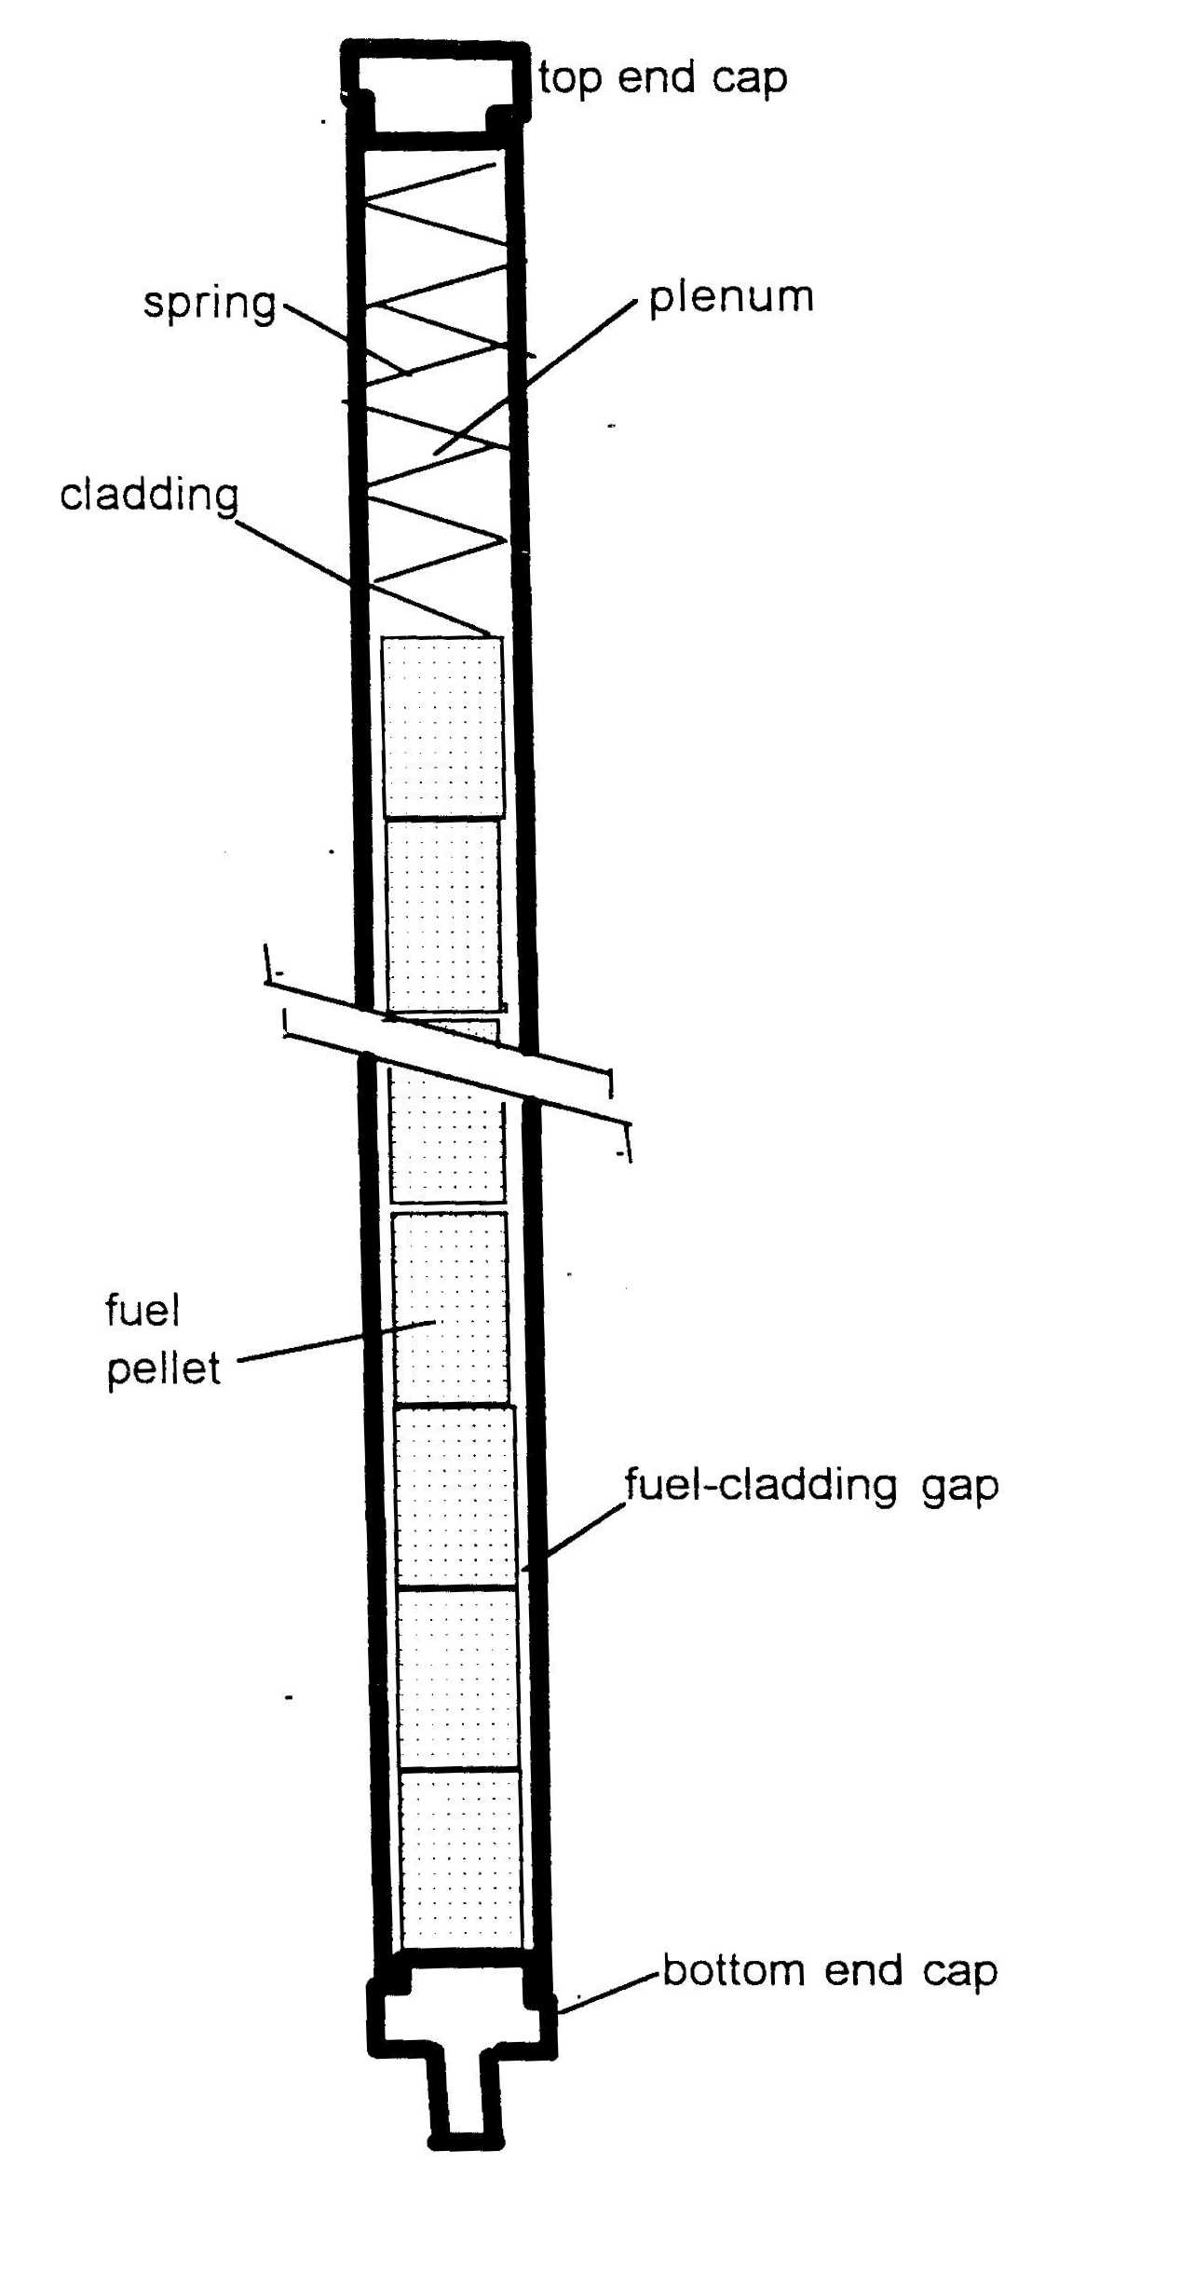

Fig 17.17 Schematic showing the main features of a light-water reactor fuel rod

inner wall is fixed by the heat flux, the temperature difference across the gap directly adds to that in the fuel. The increased fuel temperature experienced by rods with thick gaps leads to numerous undesirable consequences, the most serious of which is increased fission product release.

The thickness of the fuel-cladding gap varies in a complex manner during irradiation. When first brought to power from a cold condition, the gap partially closes due to differential thermal expansion of the pellet and the Zircaloy tube. On a short time scale (months), fine porosity in the fuel is removed by radiation densification, which shrinks the fuel and opens the gap. At a slower rate, the gap is reduced in size by fission-product swelling of the fuel in concert with creep collapse of the cladding (cladding creepdown). The latter occurs because the external (coolant) pressure outside the rod is higher than the internal pressure due in part to the He fill gas and in part to the released fission gases.

By design, the combination of the above processes leads to gap closure after 1 - 2 years at power. For this to occur, the initial cold gap radial thickness is specified in the range of 50 - 100 μm. However, contact of fuel and cladding does not assure elimination of the thermal resistance of the gap. Cladding creep collapse does not preserve the original circular shape of the tube but instead produces an oval shape that only partially contacts the fuel pellet. Moreover, even at locations of solid-solid contact, roughness of the metal and oxide surfaces and contamination of the interface by released fission products prevents tight binding. Although the thermal resistance of the closed gap is less than that of an open gap, it is not zero, and moreover, is difficult to model mathematically.

Once fuel-cladding hard contact has been made, fission-product induced swelling of the fuel produces tensile stresses in the cladding and strains the metal. If the cladding has become embrittled due to radiation damage or to accumulation of corrosion-product hydrogen, a rapid power rise can result in a through-wall crack. The fuel element has failed and releases a burst of volatile fission products (Cs, I and Xe) to the coolant. More significantly, this pellet-cladding interaction (PCI) defect admits steam to the rod interior. Corrosion of the inner cladding surface produces hydrogen that can lead to massive hydride blisters or axial cracking of the cladding that forces reactor shutdown. As discussed in Chapter 23, this can be mitigated with the use of barrier fuel, in which a Zr liner (more resistant to stress corrosion cracking than Zircaloy) is fabricated into the fuel cladding.

The temperature drop across the gap depends on the thermal conductivity of the gas as well as on gap thickness. This is the reason for choice of helium as the filling gas. However, instead of sealing fuel rods at 1 atm He pressure, pressures as high as 20 atm are used. The justification for introducing this added complexity to the fabrication process has to do with the thermal conductivity of the gas in the gap, but in an indirect way. According to the kinetic theory of gases, the thermal conductivity is independent of pressure. The reason for high-pressure helium filling is to mitigate the reduction in thermal conductivity when fission-product xenon released from the fuel mixes with the initial charge of helium in the gap. If the initial helium filling pressure is low (say 1 atm), xenon released from the fuel substantially increases the ΔT across the gap and consequently raises the fuel temperature by the same amount*. Increasing the initial helium filling pressure to the 10 - 20 atm range has been found to eliminate this problem by decreasing the effect of Xe release on gap heat transfer.

In addition to the fuel-cladding gap, the other feature of the fuel element shown in
Fig. 17.17 that is directed exclusively to minimizing potentially harmful effects of fission gas release is the plenum. This seemingly wasted space (which can be as much as 20 cm long) provides in fact sufficient volume for collecting released fission gases (Xe and Kr) without over-pressurizing the rod interior. Internal pressurization does not threaten cladding integrity during operation because the coolant pressure is generally larger than the internal rod pressure. If the opposite is true, as could occur at high burnups, the pressure difference causes the cladding to creep away from the fuel. Such displacement increases the gap width, with the attendant degradation of rod heat transfer. This phenomenon is called cladding liftoff, and is the reverse of cladding creepdown.

The fuel rods are grouped into fuel assemblies which as mentioned provide mechanical stability, a favorable geometry for coolant flow, and enhanced heat transfer. The geometric array of fuel pins or lattice has impact also on the neutron economy (changing the fuel to moderator ratio). The characteristics of fuel assemblies for different reactors are shown in table 17.5.

Table 17.5 Fuel Assembly Characteristics for BWR and PWR (adapted from [16])

 | BWR | PWR
Cladding Thickness (mm) | 0.813 | 0.57-0.65
Cladding | Zircaloy 2 | Zircaloy-4
Advanced Cladding | Barrier Zircaloy 2 | ZIRLO, M5, low-Sn Zry-4
Grid (#fuel locations) | 8 x 8 square (62) | 17 x 17 (264) or 16 x 16 (236)
Pitch (mm) | 16.2 | 12.6
Cladding outer diameter (mm) | 12.7 | 9.5-9.7
Height (m) | 4.1 | 4-4.1
Active Fuel height (m) | 3.81 | 3.6-3.8
Fuel enrichment (wt. %) | 2.8 | 3.3 (now almost 5%)
Pellet diameter (mm) | 10.4 | 8.2
Pellet Height (mm) | 10.4 | 9.5-13
Inlet Temperature (ºC) | 278 | 292-301
Outlet Temperature (ºC) | 288 | 325-332
Linear Power (kW/m) (av) | 19 | 16-17.8
max | 44 | 41-42.7
Number of assemblies | 748 | 193-241
Reactivity Control Rods | Cruciform | Rod cluster
Absorber material | B₄C | AgInCd or B₄C

The fuel assembly is held together by spacer grids which help keep the whole ensemble rigid. Some of these grids have special vanes designed to create turbulent flow and improved heat transfer and are called mixing grids. In PWR, many fuel failures have been caused by debris induced fretting. This results from debris inadvertently inserted into the reactor core during an outage which makes its way into the fuel channels and by rubbing constantly against the cladding (fretting) causes failure. These failures have been minimized by greater attention to outage practices and by debris filters that have been placed at the bottom of fuel assemblies.

Fuel rod assemblies for PWR and BWR are shown in Figure 17.18.

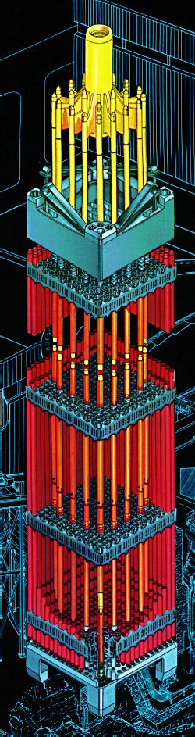 | 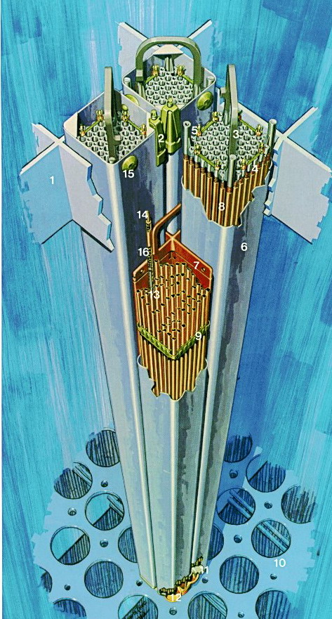

Figure 17.18: Fuel assemblies for PWR and BWR reactors (courtesy of Westinghouse and GE).

17.9 Microstructural Changes of Zr alloys under irradiation

As explained in chapters 12 and 13, the displacement of atoms induced by neutron irradiation and the interaction of these defects with the microstructure results in changes to the alloy, both in the Zr matrix and in the second phase particles.

17.9.1. Point Defects in Zr alloys

Single vacancies and interstitials as well as vacancy and interstitial clusters are formed when the material is exposed to neutron irradiation. There are different possible stable vacancy and interstitial configurations and these have been studied using molecular dynamics modeling,. As discussed in Chapter 14, in molecular dynamics (or molecular statics) simulations potentials are developed for the Zr-Zr interaction by building in the computer a crystal that exhibits the same macroscopic properties as Zr (crystal structure, lattice parameter, elastic constants, melting temperature, etc.). This crystal is then used to study the properties of defects and to determine their relative stability. These studies can also be used to determine the migration direction and migration energies for these defects.

The vacancy formation energy studied by such techniques is shown to be 1.7-2.0 eV. Figure 17.19 shows several interstitial configurations were investigated in these calculations and the most stable appear to be the octahedral (O) and basal octahedral (BO) configurations, with formation energies near 3 eV. The vacancy migration energies as determined from self-diffusion experiments in α-Zr is 1.4-1.6 eV, while the interstitial migration energies show large anisotropy, having been reported to be very low in the basal plane (jumps in the <a> direction, migration energy of 0.1 eV) compared to the direction perpendicular to it (jumps in the <c> direction, migration energy of ~ 1 eV).
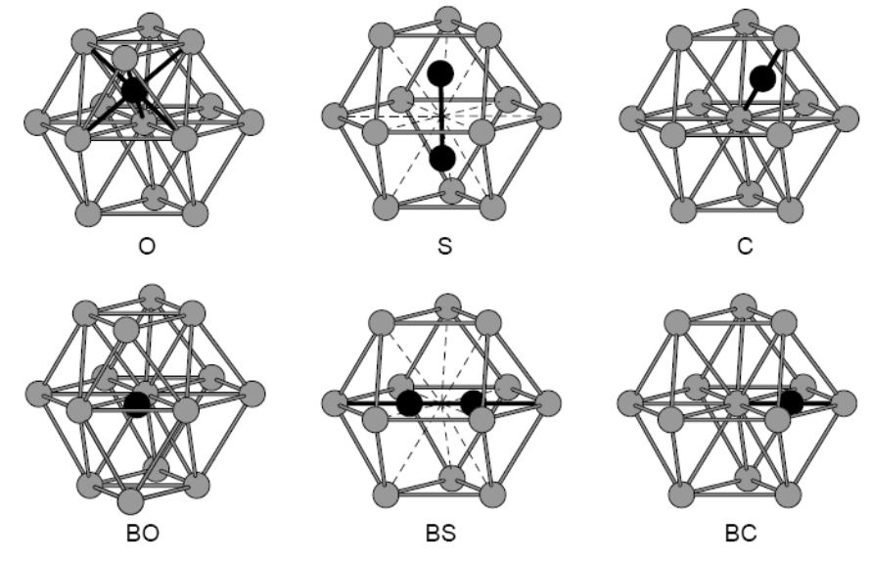

Fig. 17.19: Interstitial configurations in alpha-Zr [17]

17.9.2 Irradiation Effects in the Zr matrix

Under reactor operating temperatures, the point defects that escape immediate recombination can migrate to sinks, such as grain boundaries, free surfaces and dislocations. Due to the unequal bias of the different sinks for the defects, vacancies and interstitials can accumulate at different sinks, giving rise to macroscopic effects. For example, when network dislocations are not present in large quantities (i.e. in recrystallized material), the point defects can agglomerate into dislocation loops, causing a large increase in dislocation density. Contrary to the behavior of stainless steel, Zircaloy does not exhibit significant void formation under neutron irradiation, but it does exhibit creep and growth.

17.9.3 Dislocation Structure

The as-fabricated cold-worked stress relieved material a high density of network dislocations are present resulting from cold work. Under irradiation this material experiences little change in its dislocation structure as the existing dislocations serve as efficient sinks for the defects produced.

In contrast, recrystallized material exhibits low dislocation density in the as-fabricated state and thus an excess of point defects exist which is available to form dislocation loops of the <a> type. These are loops with Burgers Vector = 1/3 (). The density of loops formed in recrystallized material typically reaches a stationary value after about one month in the reactor. Both vacancy and interstitial loops have been reported, in roughly comparable proportions. Figure 17.20 shows both vacancy and interstitial loops in neutron irradiated pure Zr; because of the proximity of the grain boundaries on the left and bottom a region appears where no interstitial loops are present (interstitials are mobile and can be annihilated at the grain boundaries). This is an unusual feature of irradiation induced microstructural development in Zr and its alloys, as compared to cubic metals and other hcp metals, where only one type of loop (interstitial or vacancy loop) usually grows. The a type dislocations arrange themselves in layers, parallel to the basal plane. Vacancy loops exist at temperatures between 353 and 723 K, above which temperature they are destabilized by vacancy thermal emission.

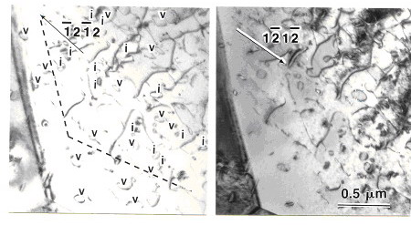
Figure 17.20: Transmission electron micrograph showing dislocation loops in pure Zr after irradiation to 1.5 x 10²⁶ n.m⁻² at 700 K. Loops can be identified as vacancy or interstitial in nature by how their contrast changes when the diffraction conditions are changed (photo courtesy M. Griffiths, AECL).

After neutron irradiation to a dose near 3 x 10²⁵ n.m⁻² at temperatures between 560 and 773 K, c-component dislocations start to develop in annealed Zircaloy-2. They are located on the basal plane, are vacancy in character and have a 1/6 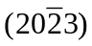 Burgers vector. It is not known what triggers the appearance of c component loops after the aforementioned dose, but their appearance has been linked to the occurrence of breakaway growth by providing an additional sink for vacancies, as explained in chapter 22.

Finally, irradiation can dissolve and/or modify the precipitates present in the as-fabricated alloy. This causes the distribution of alloying elements to change under irradiation. The mechanisms whereby this happens in Zr alloys are outlined in chapter 24. The redistribution of alloying elements can have significant impact on in-reactor behavior of fuel cladding. From the above, both the matrix and the precipitates changes under irradiation. These microstructure changes have consequences for in-reactor behavior of Zr alloys, affecting mechanical properties (chapter 23), waterside corrosion (Chapter 18), stress corrosion cracking (Chapter 22) and irradiation growth and creep (chapter 20).

Problems

17.1. The normal Hf content in Zr ore is about 2%. Calculate the microscopic thermal neutron cross section of Zr prepared from such a material, in the absence of any Hf separation.

17.2. Given the ZrFe phase diagram shown in Chapter 2, discuss what phases would be present upon cooling of a melt of 95%Zr and 5%Fe (atom%) from 200 C to room temperature. Write down the equations and give the equilibrium phase transformations and compositions at 1500ººC, 1200º C, 900ºC and 500º C.

17.3 The normal basal pole figure of a Zr sheet component is given below where R is the rolling direction, and T is the transverse direction. Sketch the prismatic (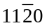) normal pole figure corresponding to the above.

17.4 It is desired to measure the basal pole texture of a piece Zircaloy sheet using x-ray diffraction.

- Calculate the two theta diffraction angle if CuK_{α} radiation is used (λ= 0.15414 nm).
- Given the basal pole figure in Figure 17.14, calculate f_{T}, f_{R} f_{N} by a numerical approximation of the measured areas in the plot. Group the successive lines onto 0-0.5, 0.5- 1,1- 4, 4-7 and 7-9 times the average intensity.
- Calculate the effective thermal conductivity of this rolled sheet in the three macroscopic directions.

17.5 In a non-ideal hexagonal lattice (one where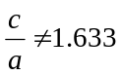), would you expect a larger than ideal c/a ratio ( 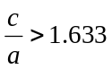) to favor basal or pyramidal/prismatic slip? Why?

References

[1] D. L. Douglass, The Metallurgy of Zirconium. Vienna: International Atomic Energy Agency Supplement, 1971.
[2] B. Lustman and F. Kerze, Metallurgy of Zr. New York: McGraw-Hill, 1955.
[3] E. Tenckhoff, Deformation Mechanisms, Texture and Anisotropy in Zirconium and Zirconium Alloys, vol. 966. Philadelphia: ASTM, 1988.
[4] C. Lemaignan and A. T. Motta, "Zirconium Alloys in Nuclear Applications," in Materials Science and Technology, A Comprehensive Treatment, vol. 10 B, Nuclear Materials, B. R. T. Frost, Ed. New York: VCH, 1994, pp. 1-51.
[5] B. A. Cheadle, "Physical Metallurgy of Zr alloys," Chalk River National Laboratory CRNL-1208, 1975.
[6] S. Kass, "The Development of the Zircaloys," Symposium on Corrosion of Zirconium Alloys, ANS Winter meeting, 1963, New York, (1964), ASTM, vol. STP 368, 3-27.
[7] W. G. Burgers, Physica, vol. 1, (1934), 534-546.
[8] A. Kelly and G. W. Groves, Crystallography and Crystal Defects. Reading, MA: Addison-Wesley Pub. Co., 1970.
[9] G. M. Hood, "Point Defect Diffusion in alpha-Zr," Journal of Nuclear Materials, vol. 159, (1988), 149-175.
[10] G. M. Hood, H. Zou, R. J. Schultz, J. A. Roy, and J. A. Jackman, "Hf Diffusion in Pure and Ultrapure α-Zr," Journal of Nuclear Materials, vol. 189, (1992), 226-230.
[11] C. H. Woo, "Effects of Anisotropic Diffusion on Irradiation Deformation," 13th Radiation Efefct on Materials Symposium, (1986), ASTM, vol. STP 955, 70-89.
[12] F. Laves, "Factors governing structure of intermetallic phases," Advances in X-Ray Analysis, vol. 6, (1963), 43-61.
[13] G. L. Garner and J. P. Mardon, "Performance of Alloy M5 in a High Duty U.S. Reactor," Nuclear Engineering International, (2002), 36.
[14] J. J. Kearns and C. R. Woods, J. Nucl. Mater., vol. 20, (1966), 241.
[15] M. T. Simnad, "Review of Fuel Element Development for Water Cooled Nuclear Power Reactors," IAEA Tech Report series 299, 1989.
[16] R. A. Knief, Nuclear Engineering. Washington and London: Taylor and Francis, 1992.
[17] F. Willaime, "Ab initio study of self-interstitials in hcp-Zr," Journal of Nuclear Materials, vol. 323, (2003), 205-212.

* The thermal conductivity of Xe is only 5% that of He

